Dear Parents,
RE: FIRST WEEK BACK - 1st June 2020
Assalaamu alaikum warahmatullahi wabarakatuhu,
I hope you are in the best of health, I am writing to inform you that alhamdullilah we have had a successful reopening at Al-Emaan during this difficult time. Everything is going well as we have been observing social distancing, separated our main room and have extended our outdoor area for children to enjoy more time in the outdoor environment. These changes will enable all children to stay safe and play alongside their friends.
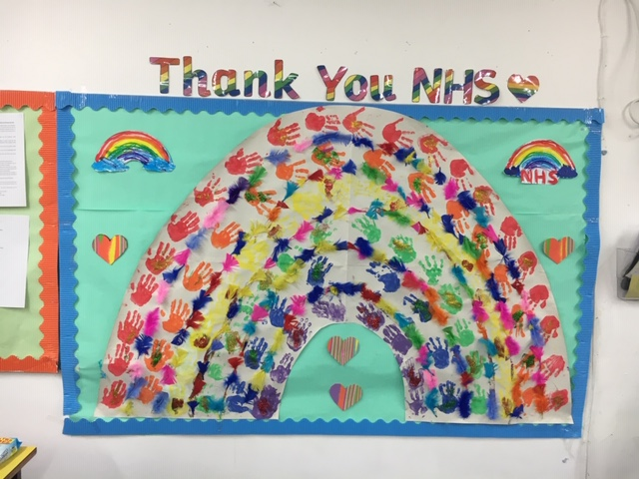
NHS Thank You Display created by all our children who have attended since 1st June 2020.
The current children who are attending the setting are having a very enjoyable time! This week we have created beautiful Eid cards in celebration of Eid. Children have also learnt about the Coronavirus. We have introduced ‘The hand washing song’ to ensure children are monitored and taught how to wash their hands effectively and correctly to minimise the spread of this virus. Children have been taught what to do when they have coughed/sneezed to stop the spread. We have also read child friendly books explaining the virus.
During the remainder of the week inshaAllah, children will be making a hospital (junk modelling) using a variety of resources as well as making a NHS thank you display.
Eid cards and ‘Happy to be back’ Cards 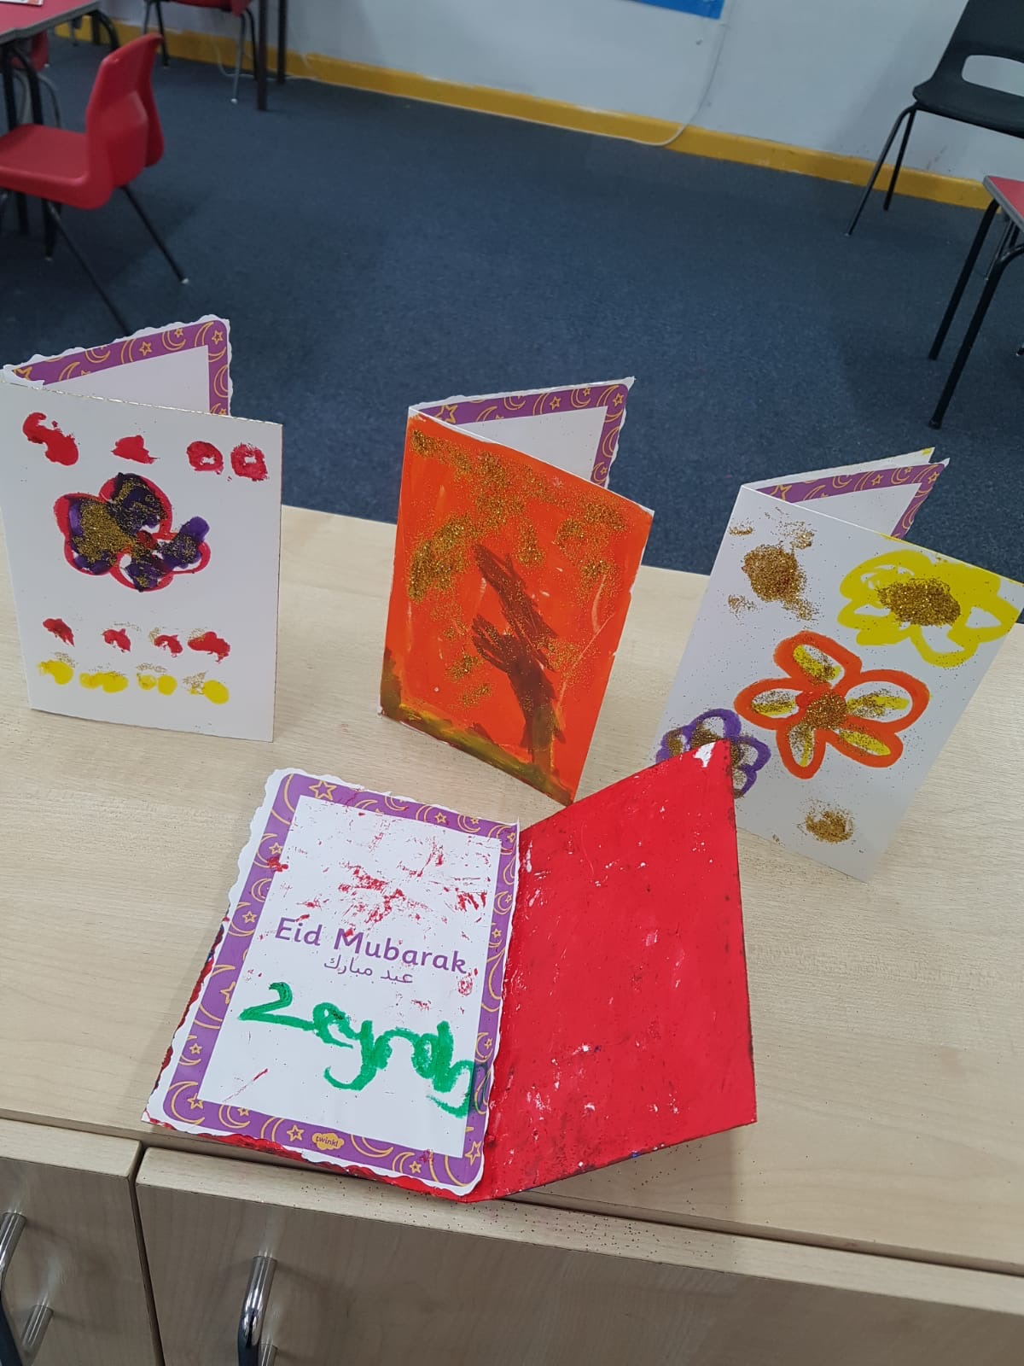
Our main priority at Al-Emaan is to ensure children are kept safe hence we have made changes for children to play, learn and develop in a secure environment. We have put all safety measures possible by government guidelines in place. We hope that this letter is reassuring you that your child is in a happy and safe place and will encourage all parents to bring their children in. We are missing all our children.
Jazakallah for your time,
Assalaamu alaikum warahmatullahi wabarakatuhu
The Al- Emaan Nursery Team

